**Week 3**

**K-Nearest Neighbours**

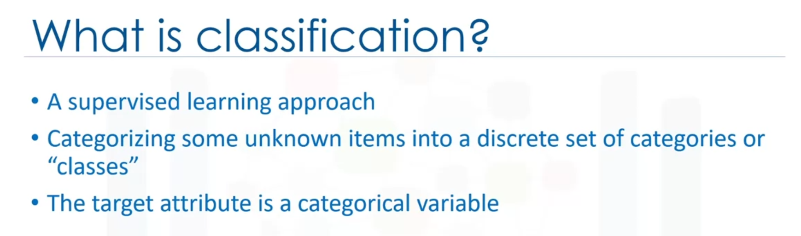

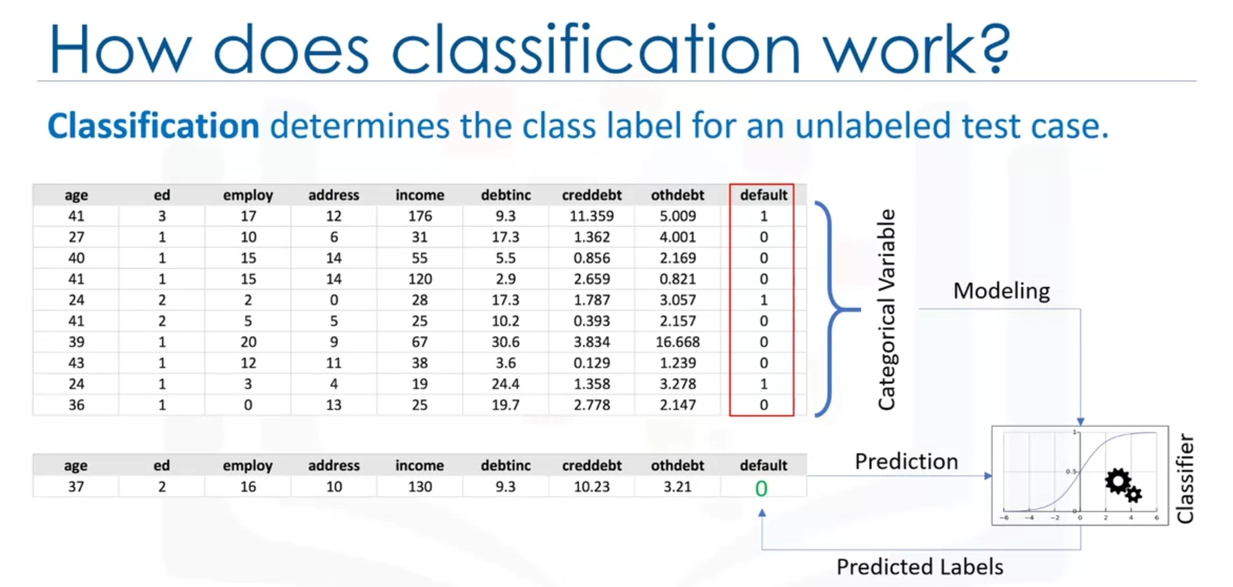

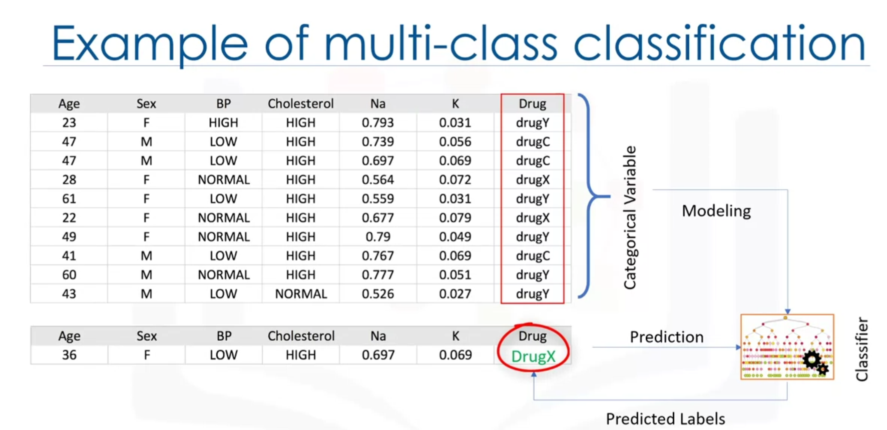

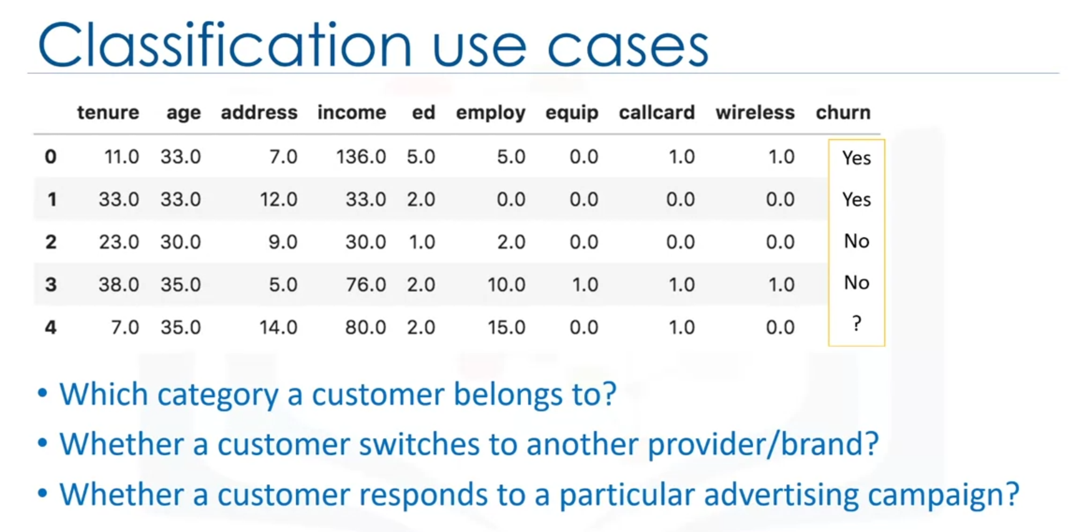

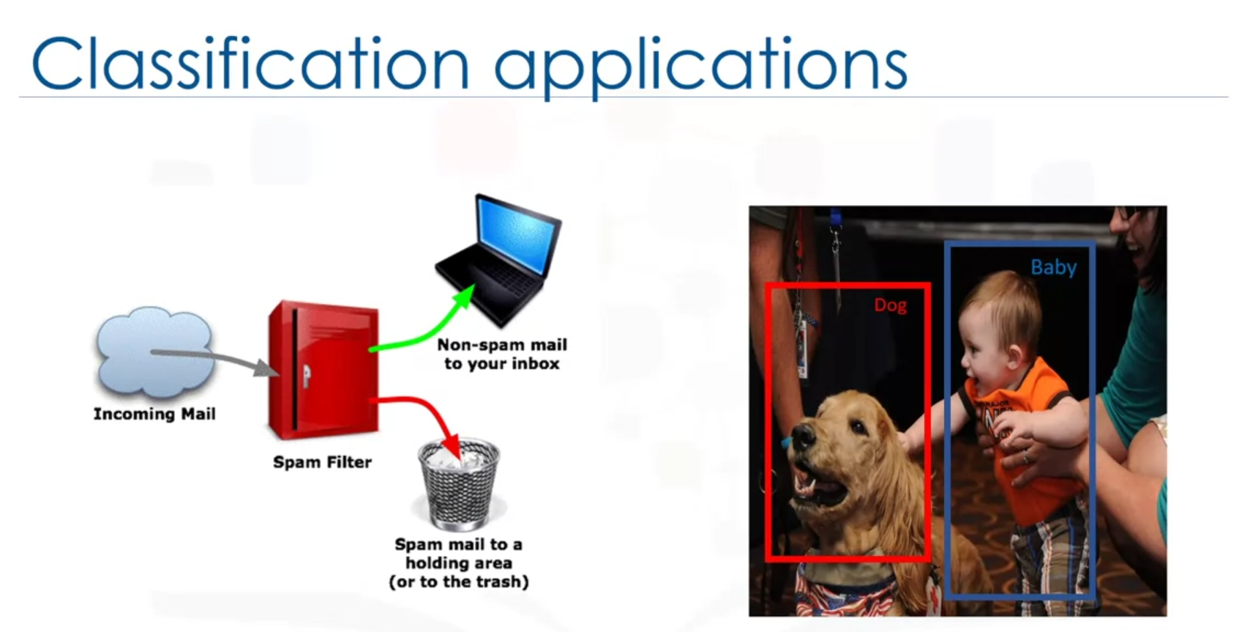

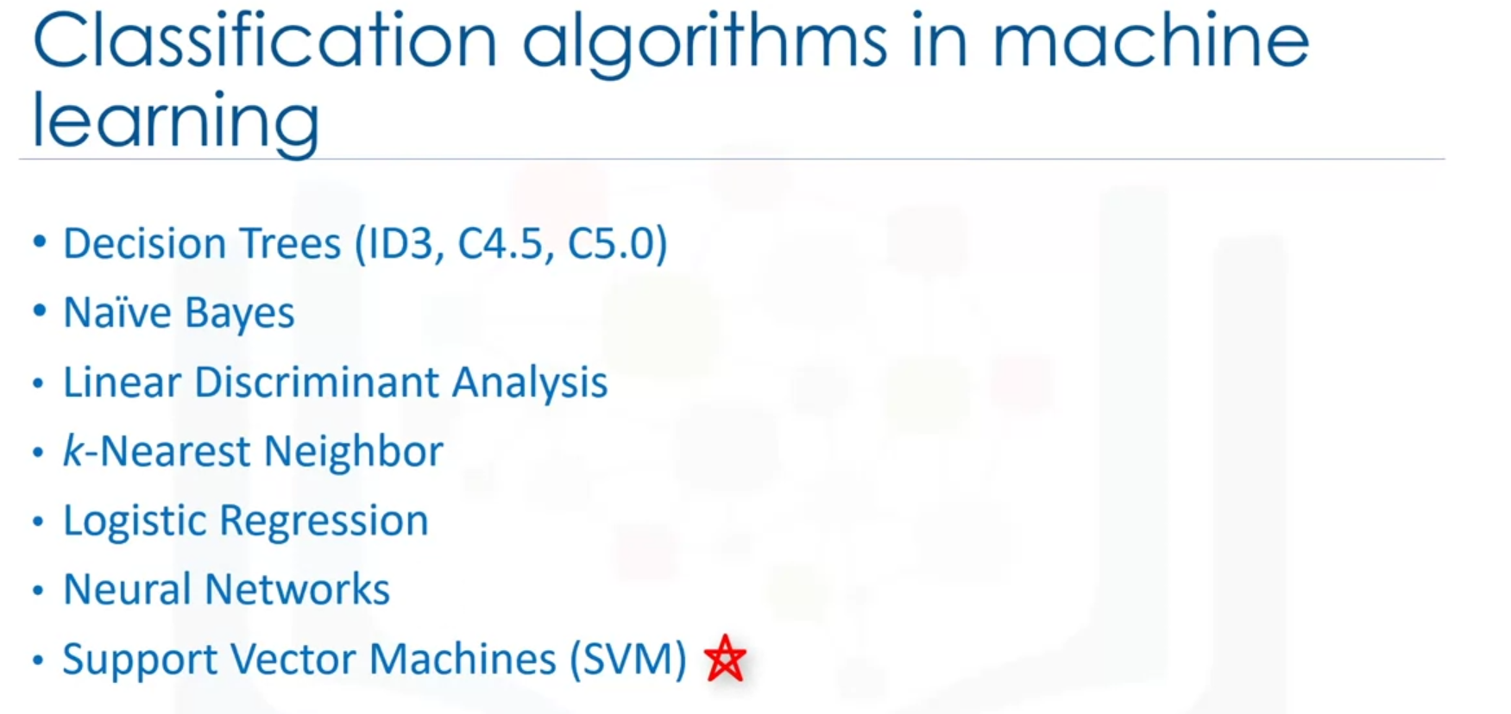

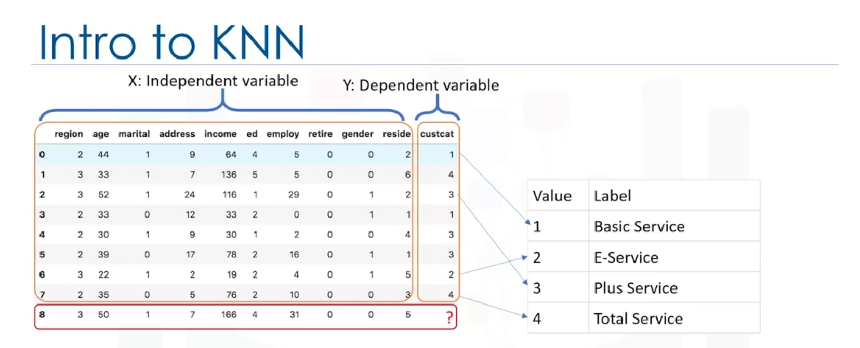

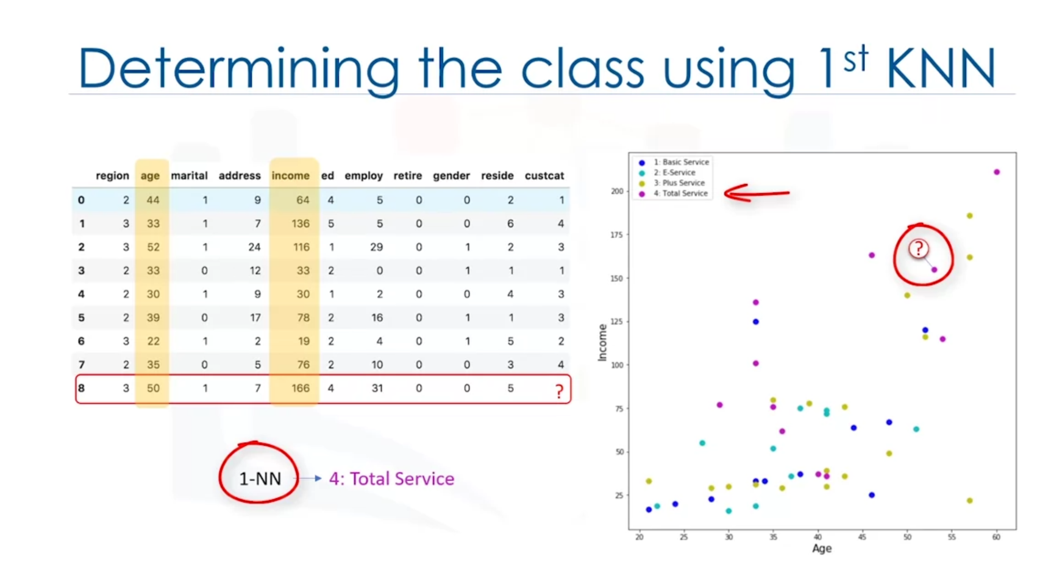

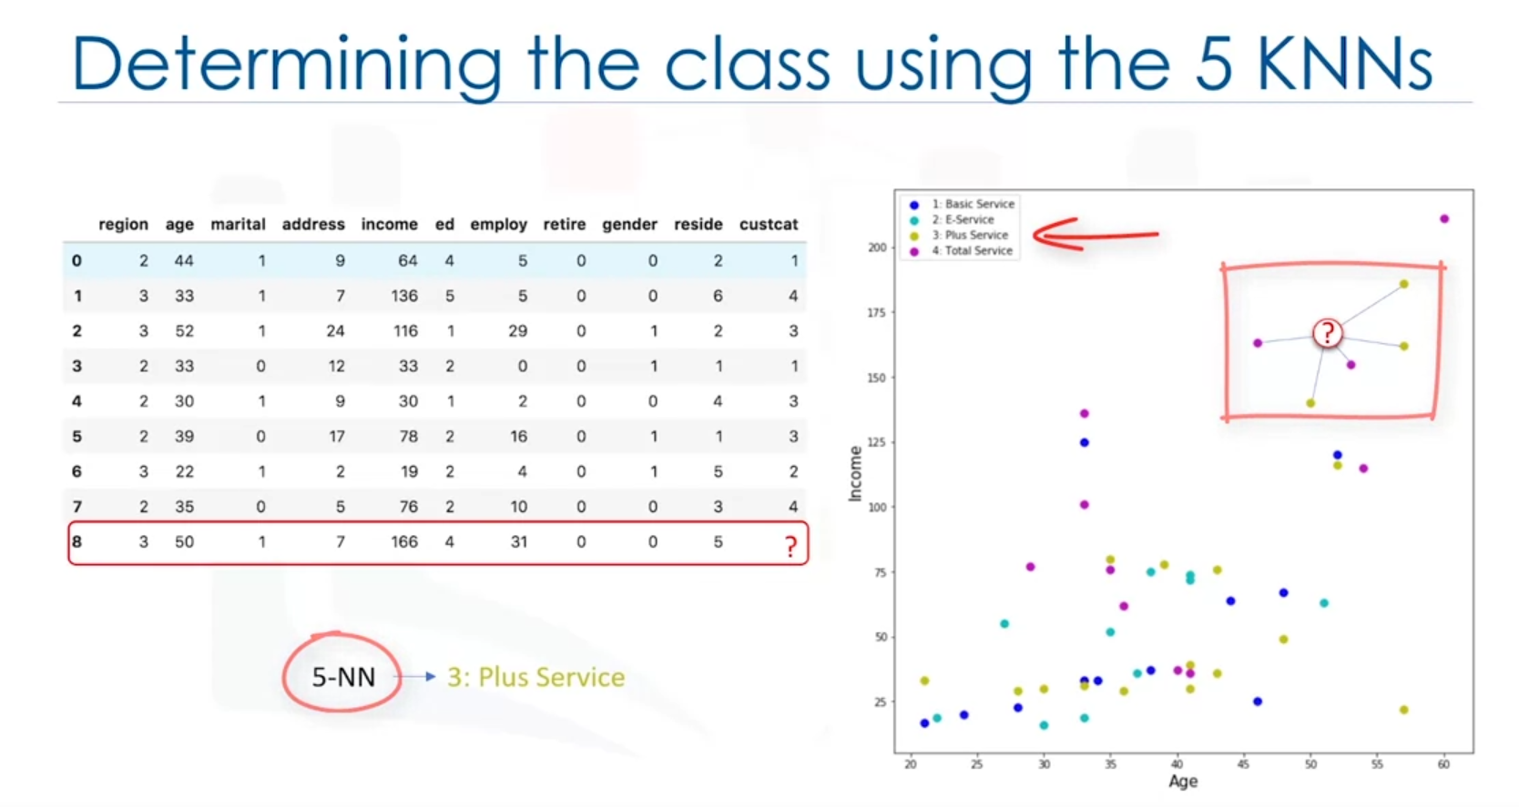

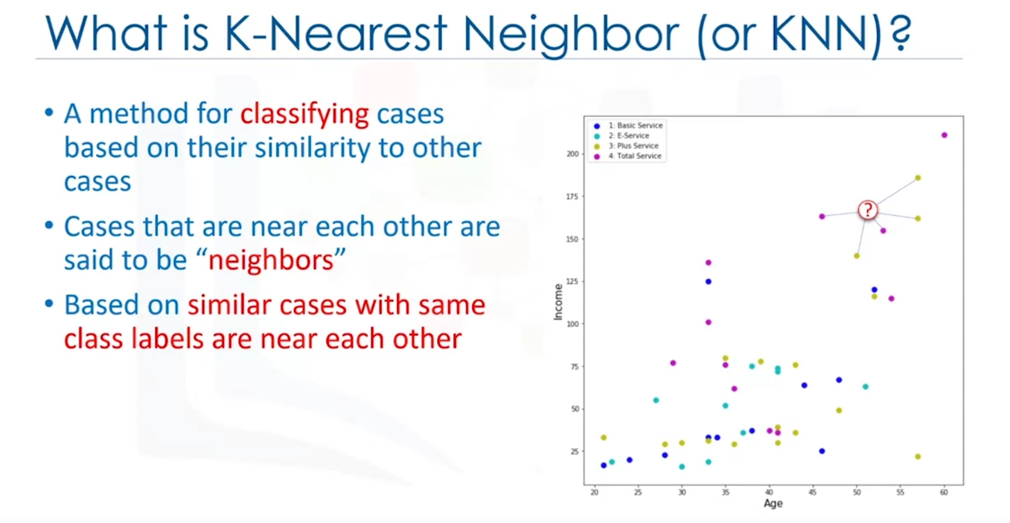

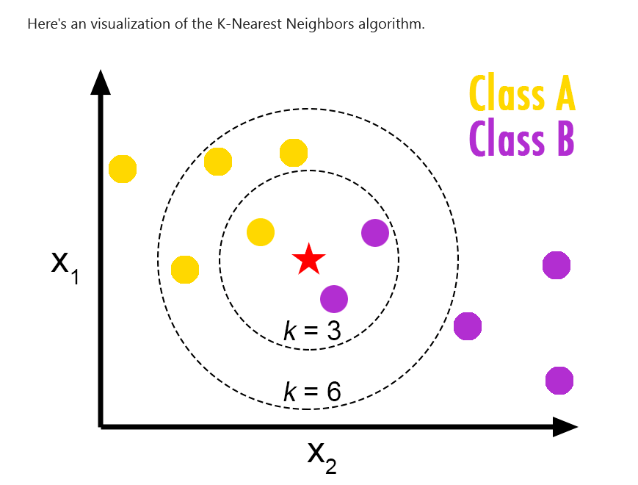

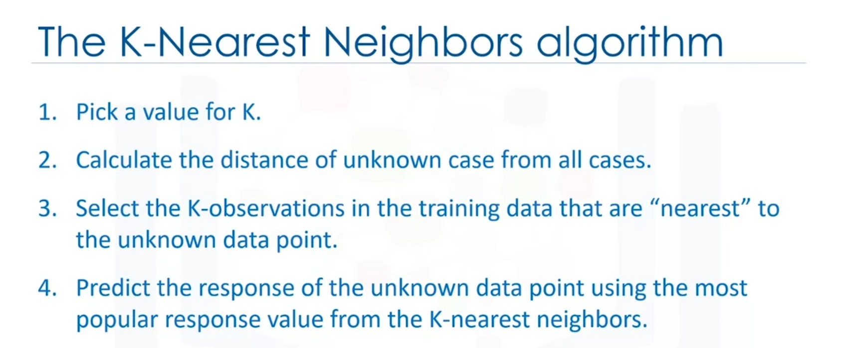

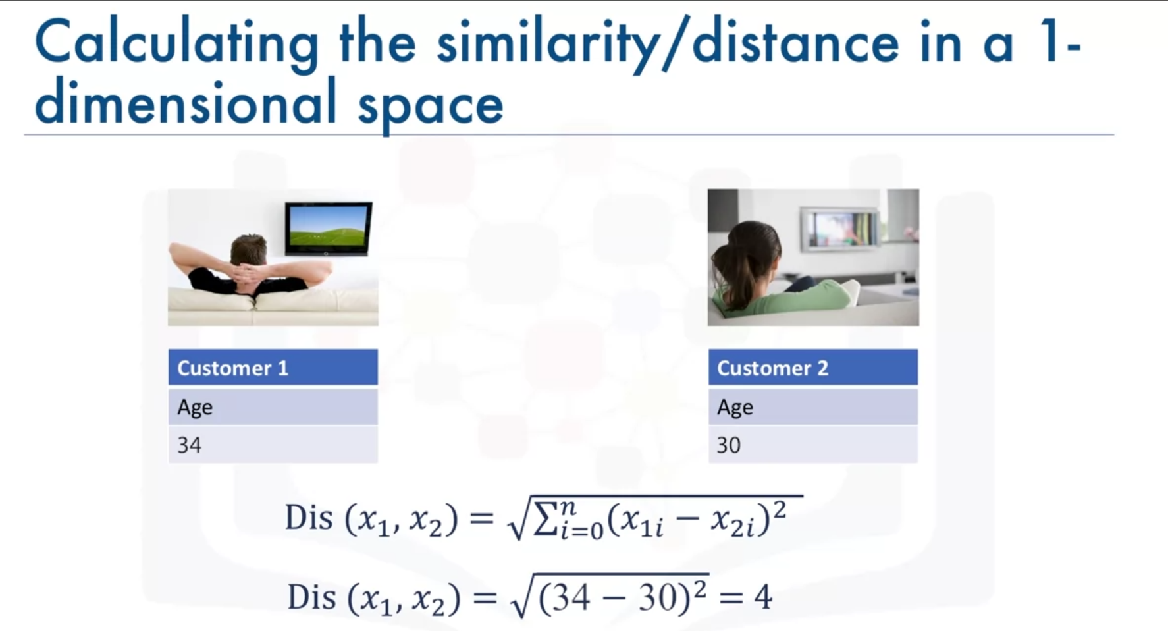

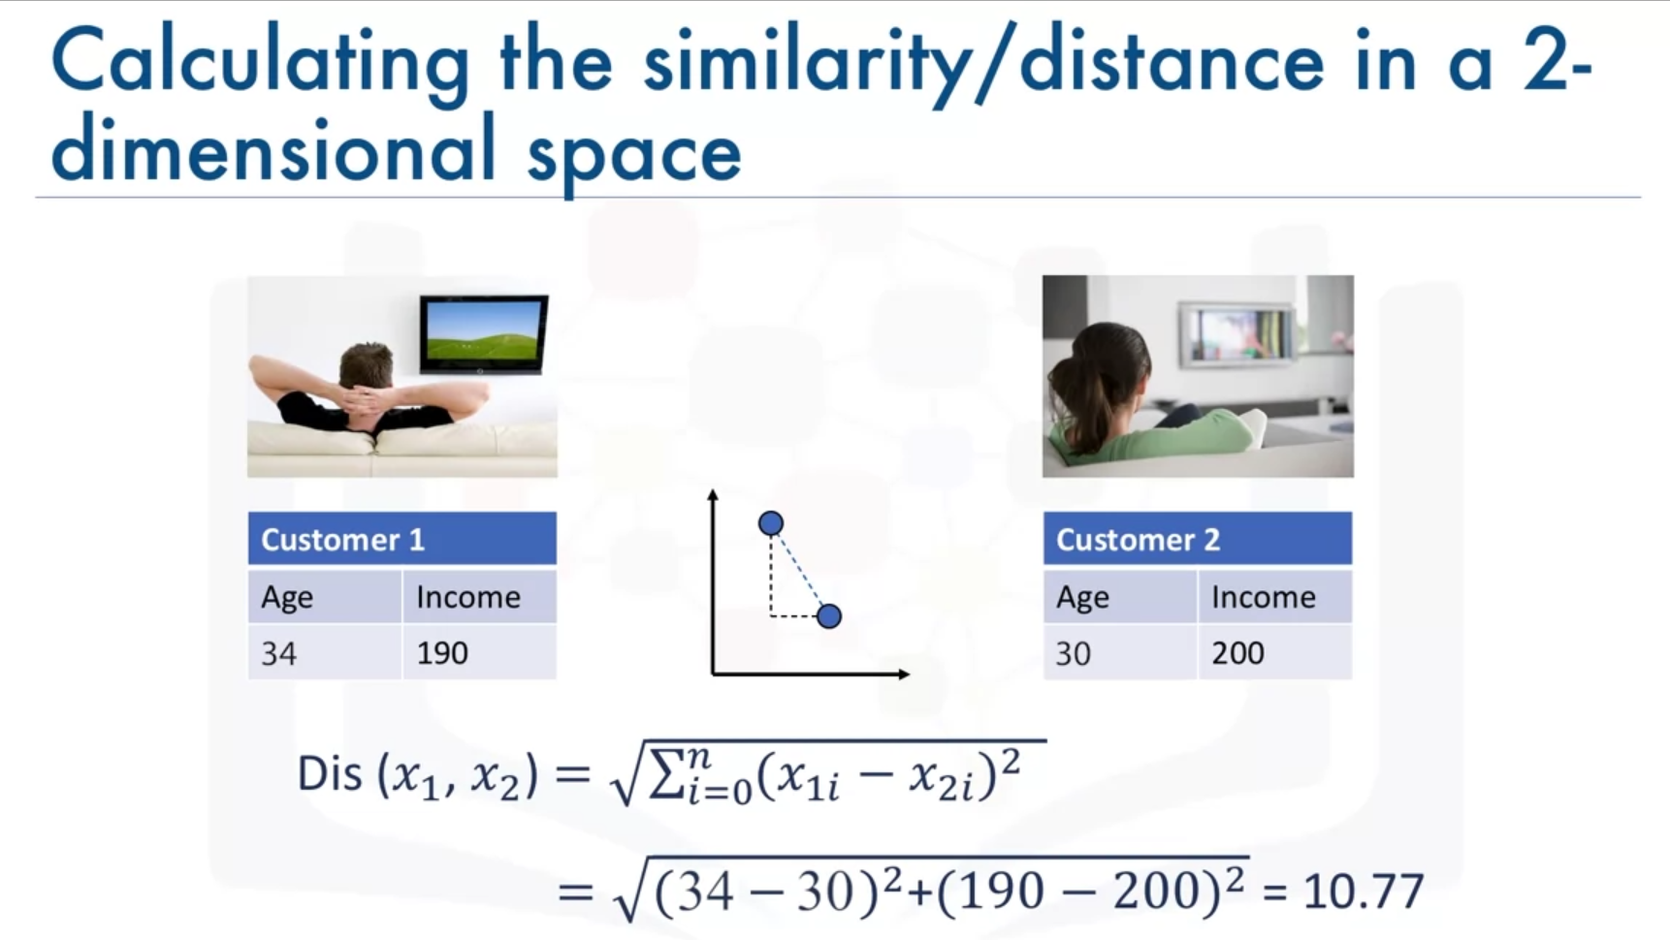

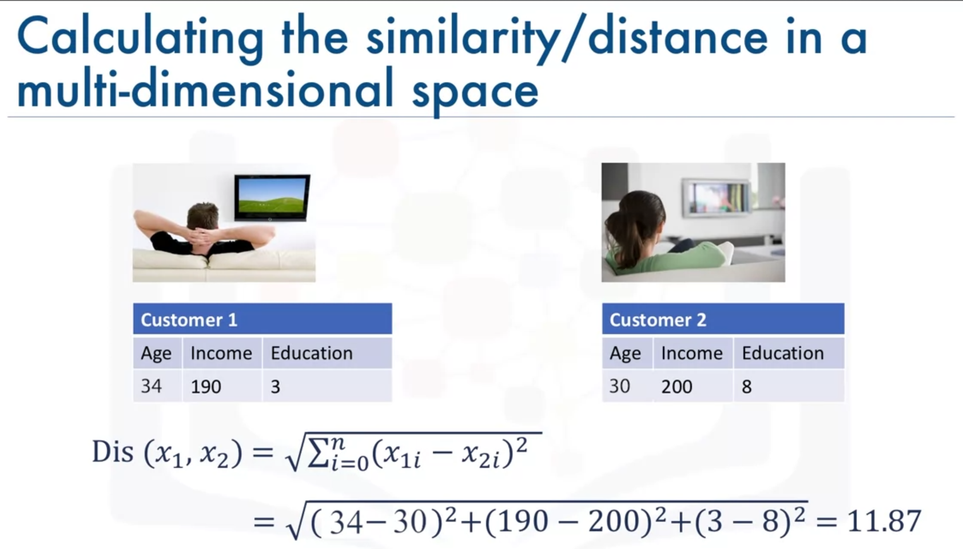

Low value of k = can lead to overfitting of the model.

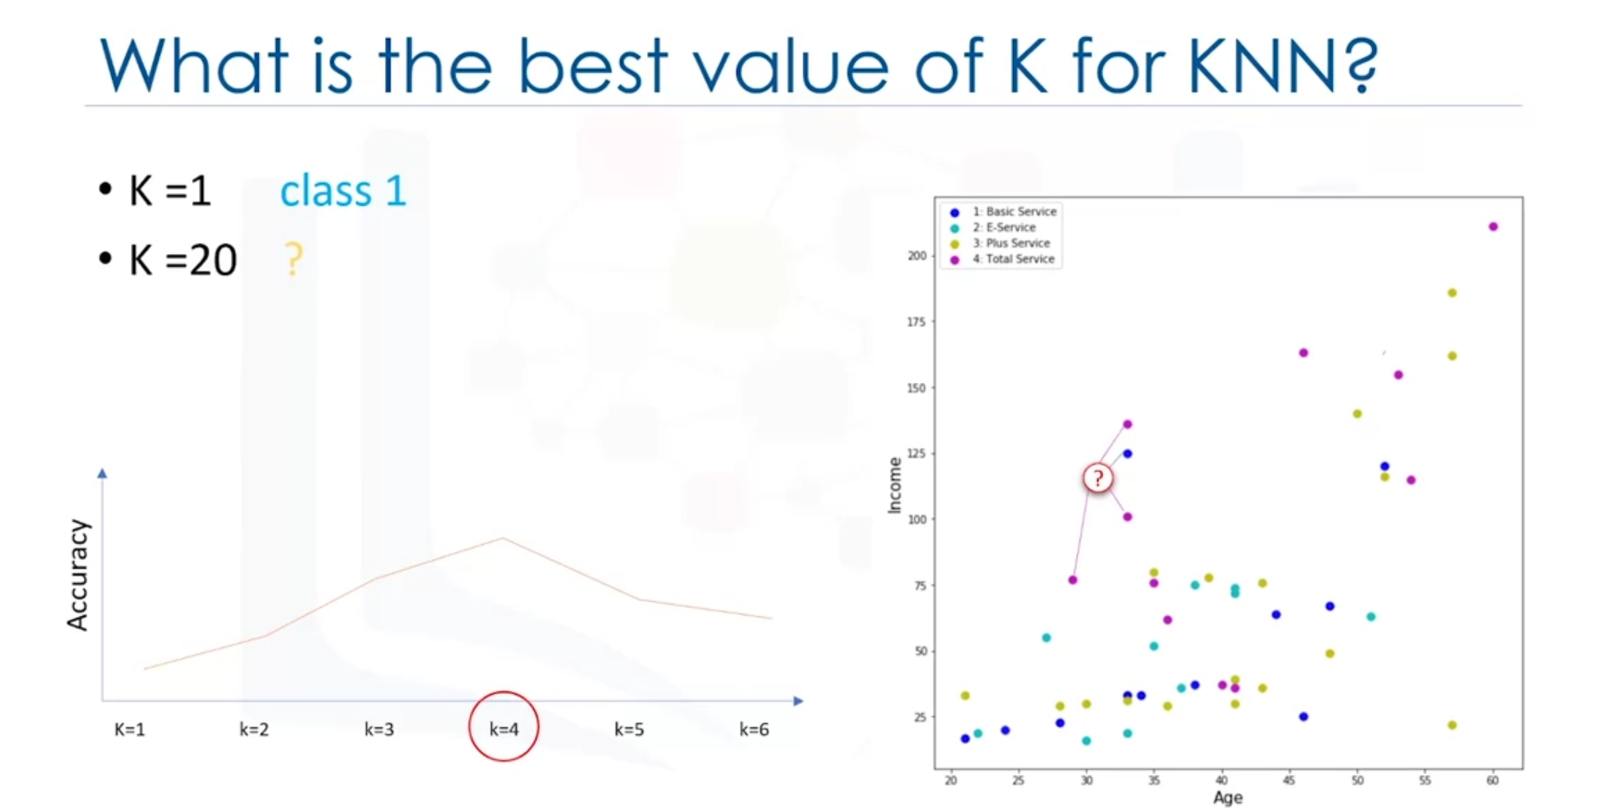

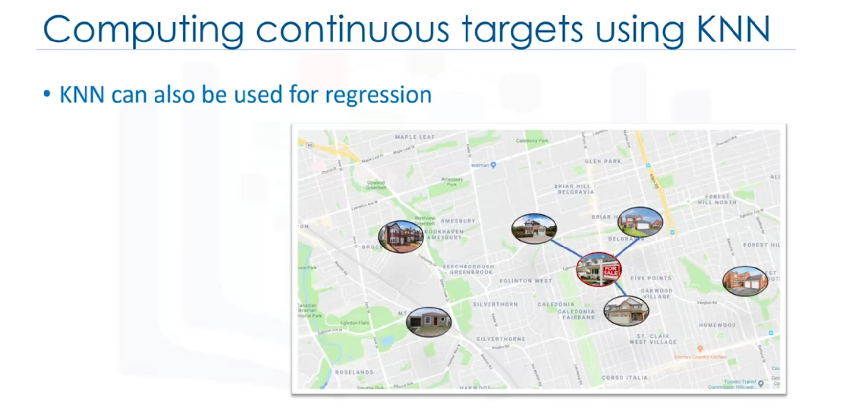

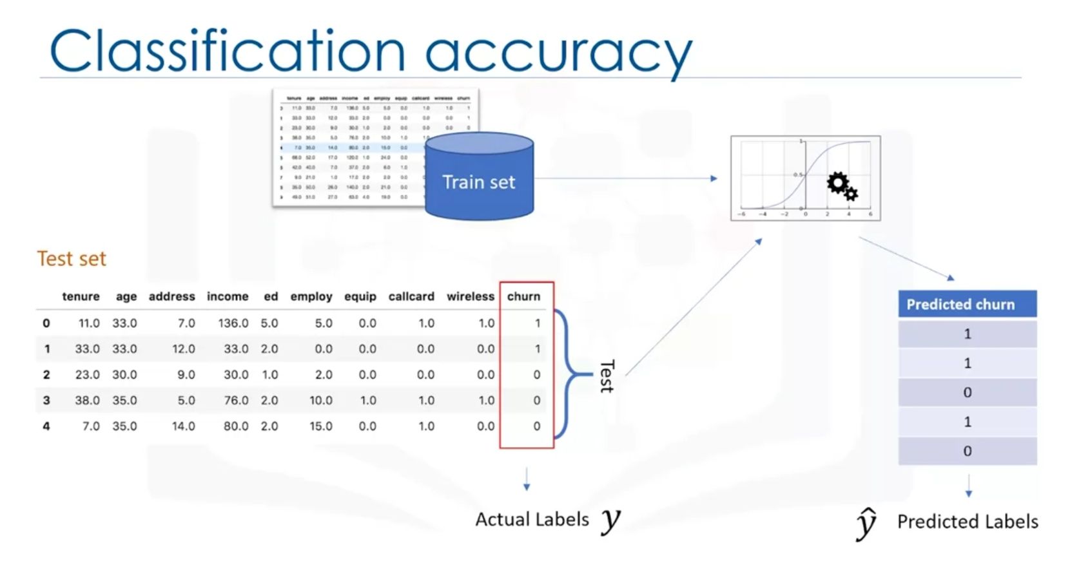

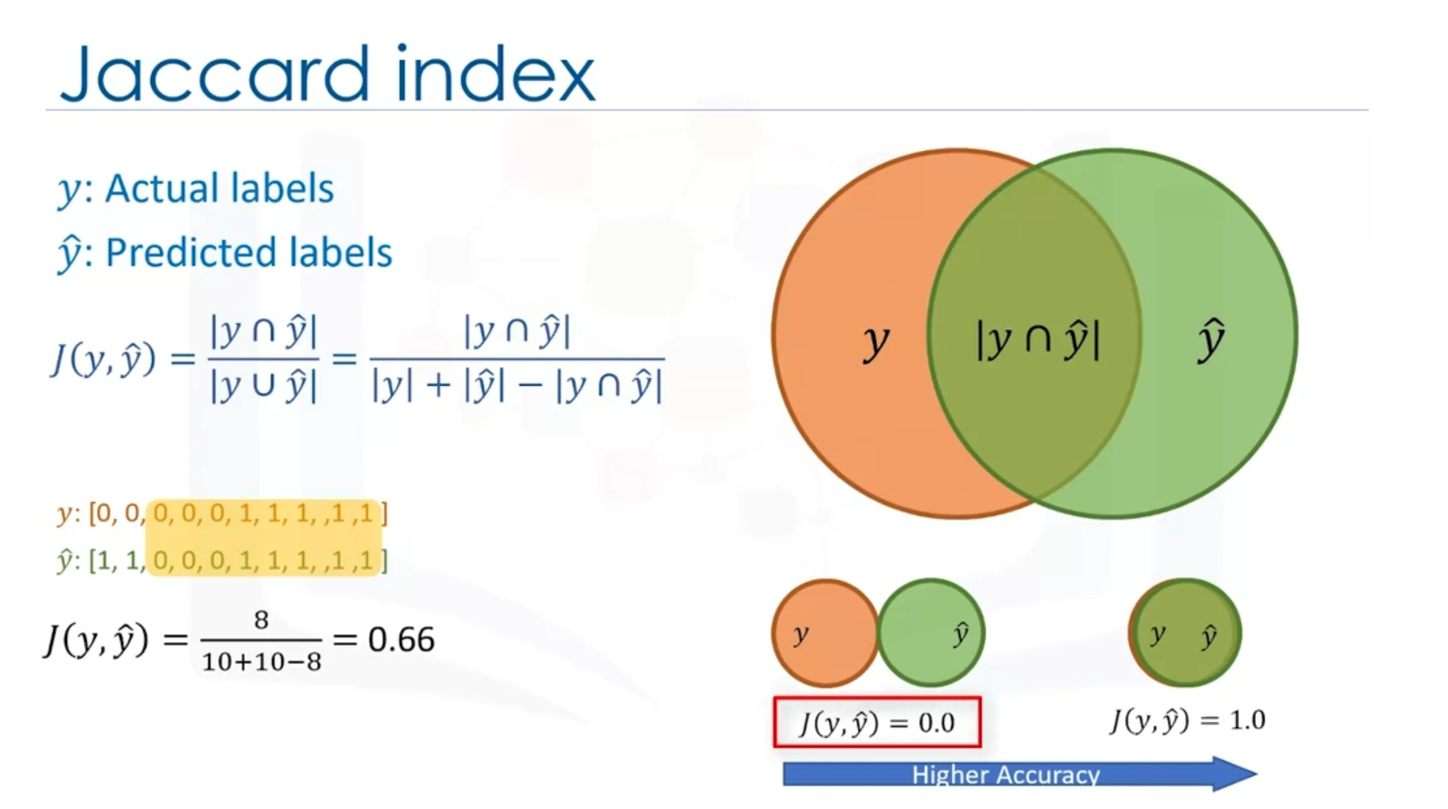

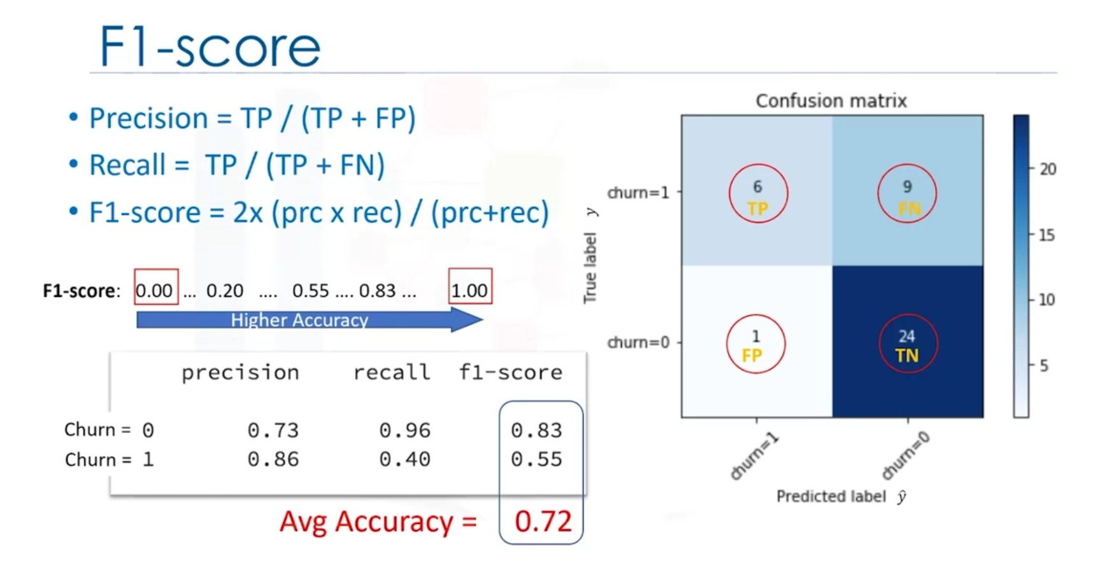

F1-score higher better.

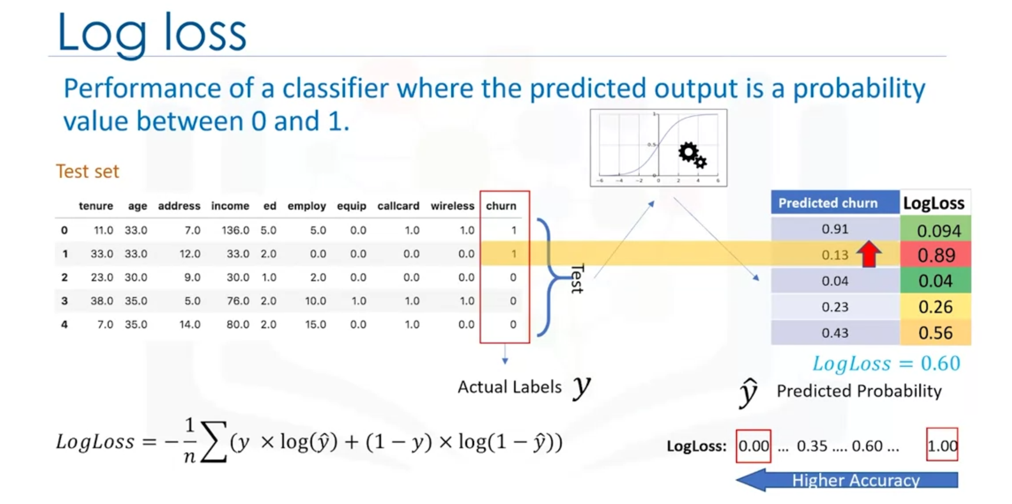

LogLoss classifier close to 0 is better.

Out of Sample Accuracy is the percentage of correct predictions that the model makes on data that the model has NOT been trained on. Doing a train and test on the same dataset will most likely have low out-of-sample accuracy, due to the likelihood of our model overfitting.

It is important that our models have a high, out-of-sample accuracy, because the purpose of any model, of course, is to make correct predictions on unknown data. So how can we improve out-of-sample accuracy? One way is to use an evaluation approach called Train/Test Split. Train/Test Split involves splitting the dataset into training and testing sets respectively, which are mutually exclusive. After which, you train with the training set and test with the testing set.

This will provide a more accurate evaluation on out-of-sample accuracy because the testing dataset is not part of the dataset that has been used to train the model. It is more realistic for the real world problems.

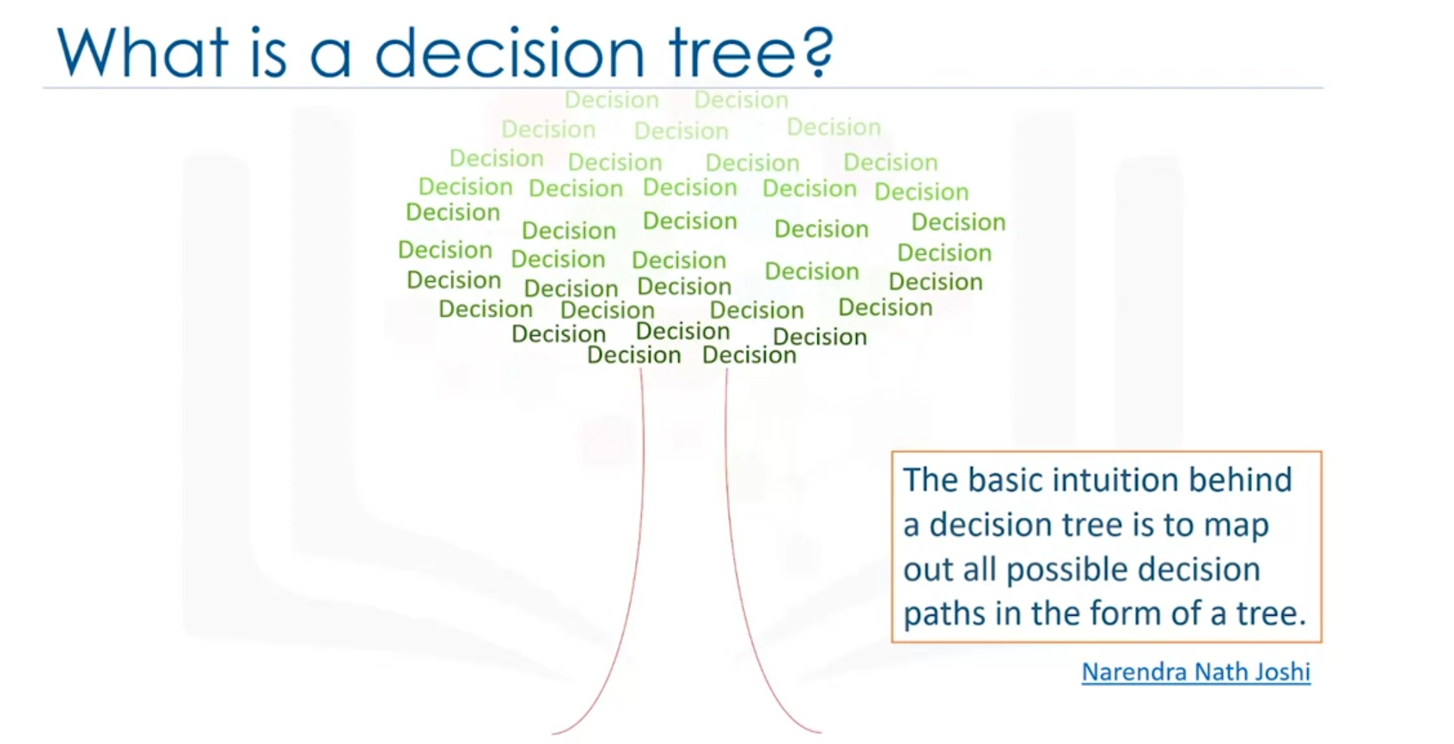

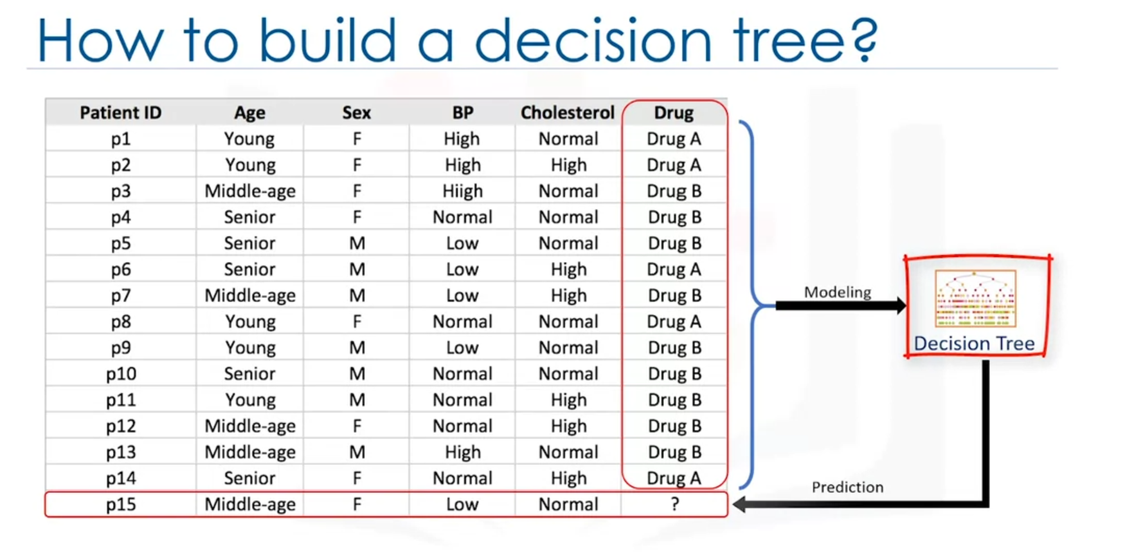

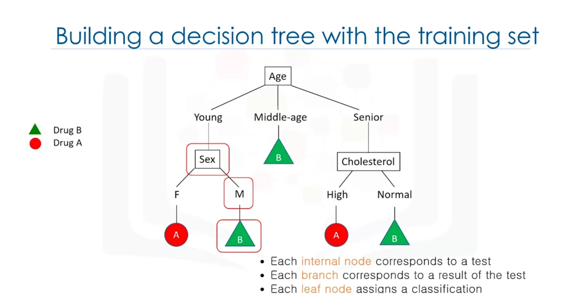

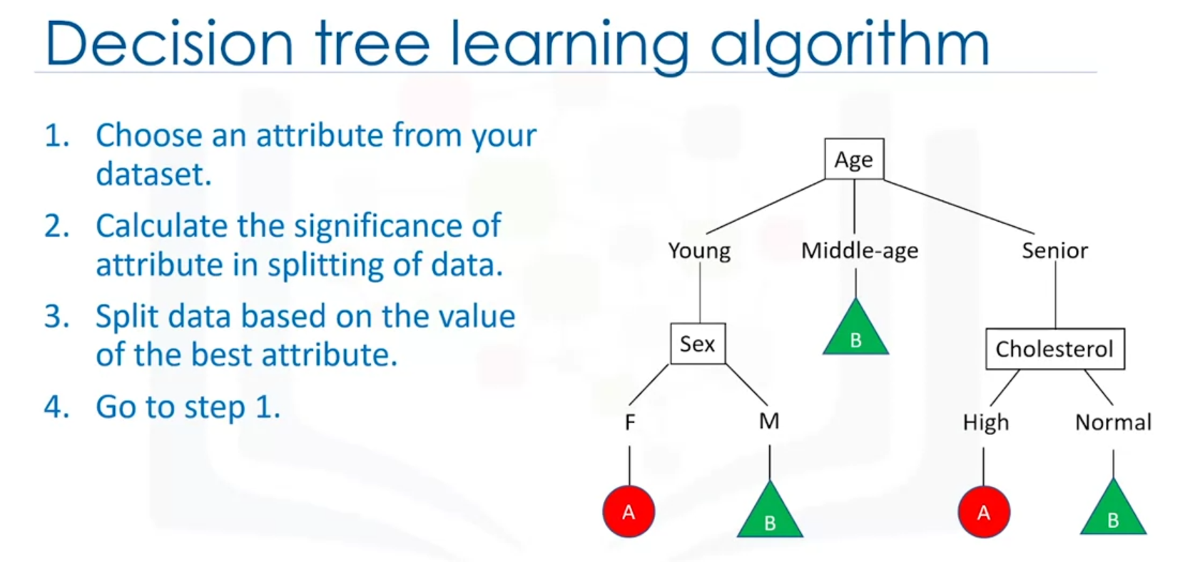

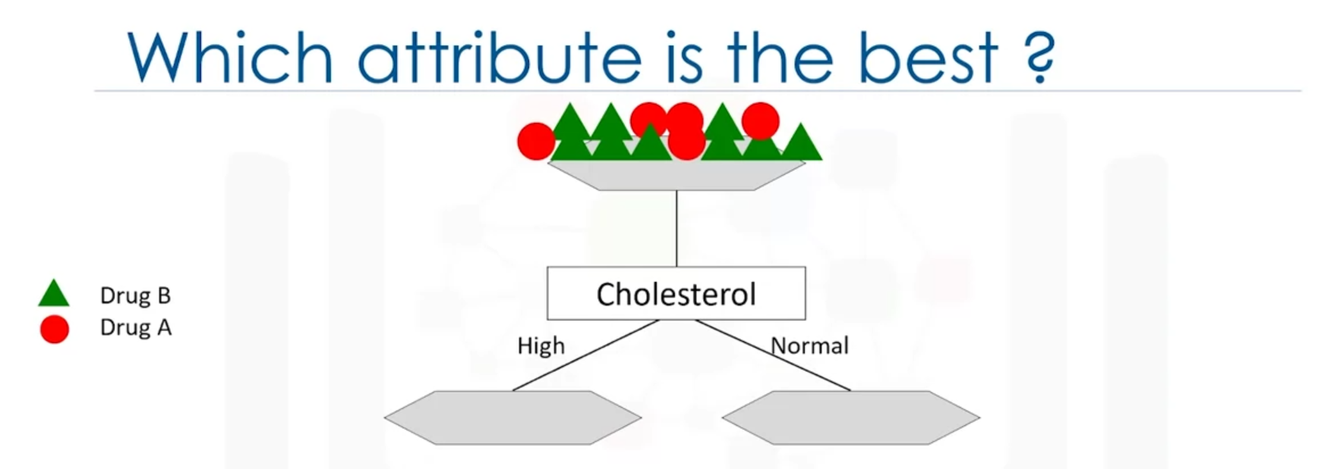

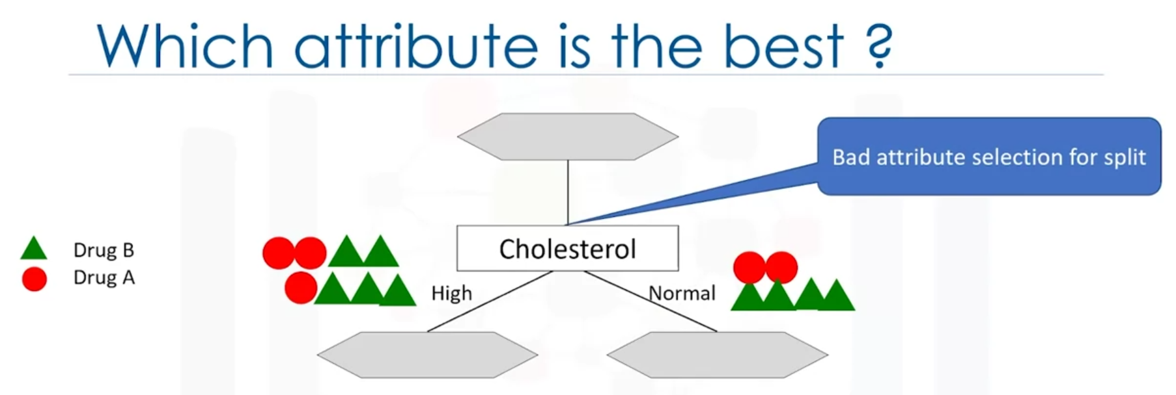

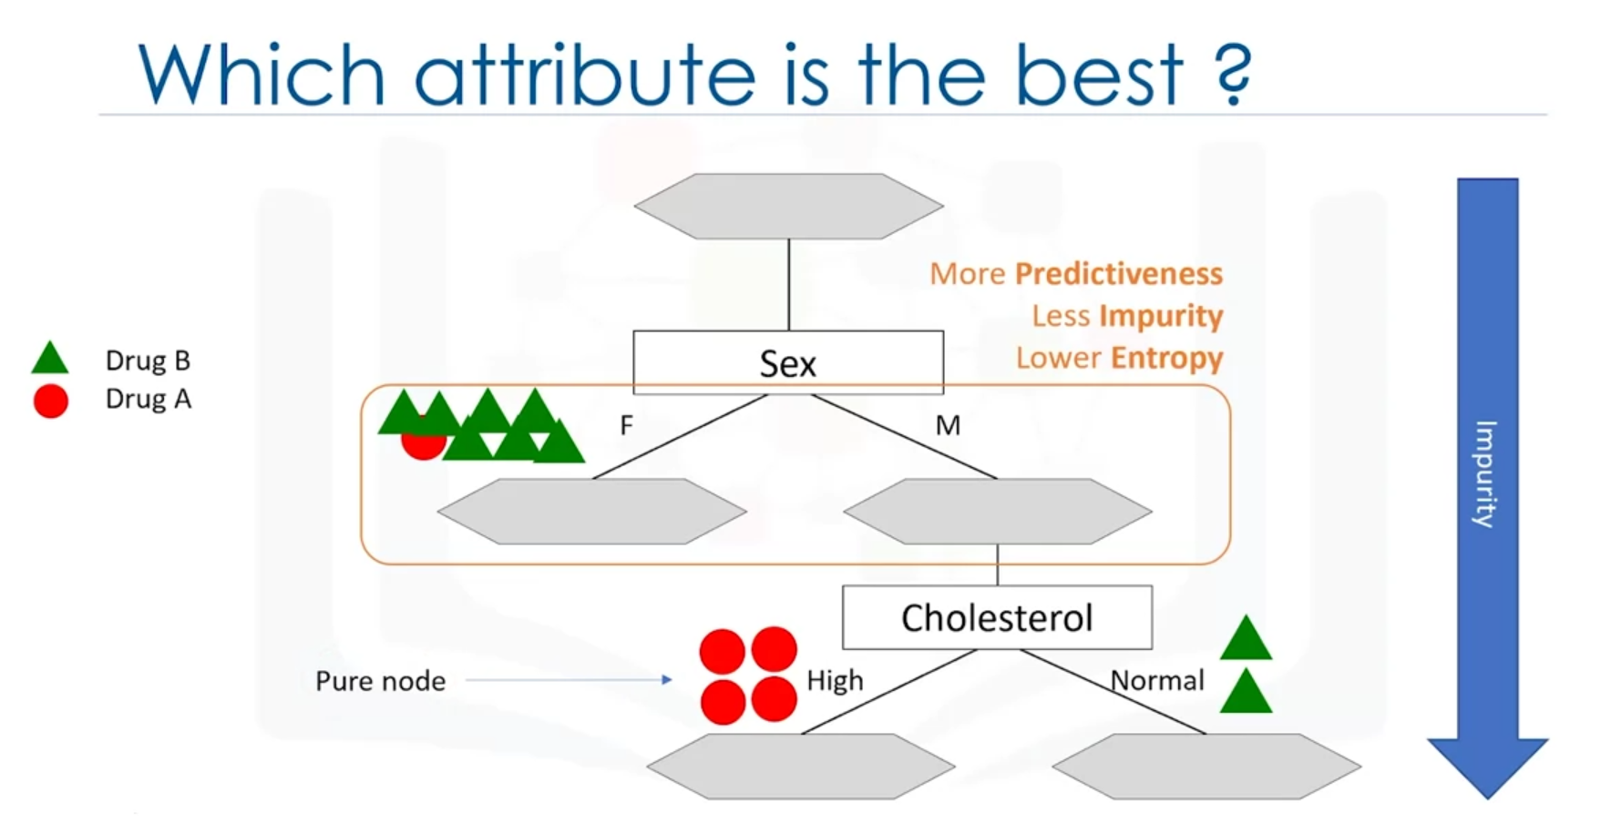

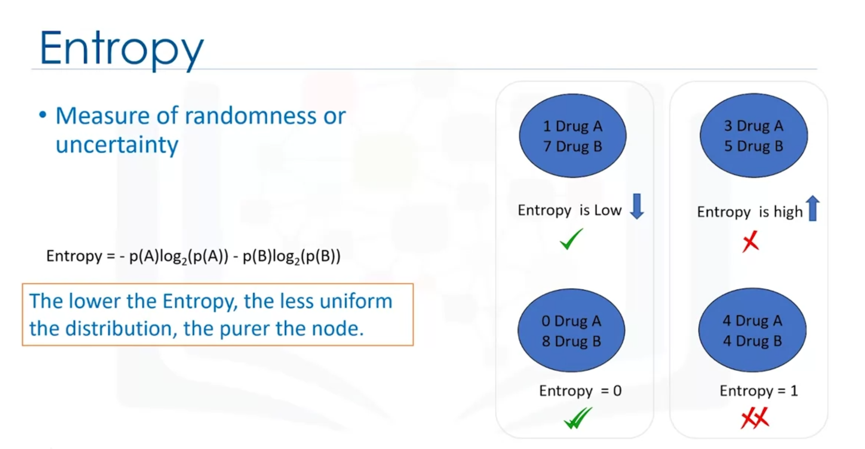

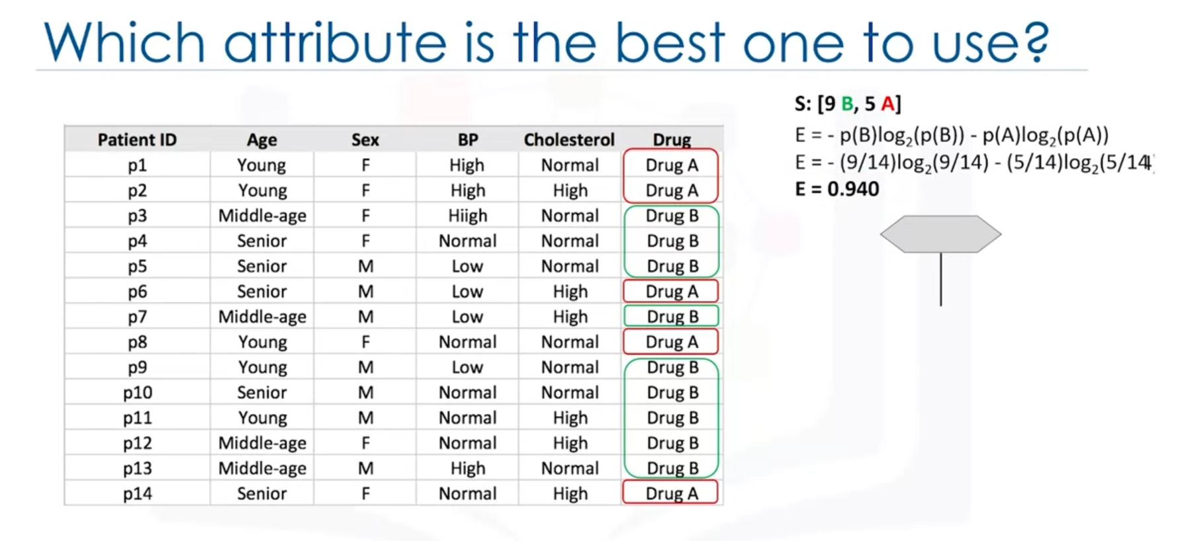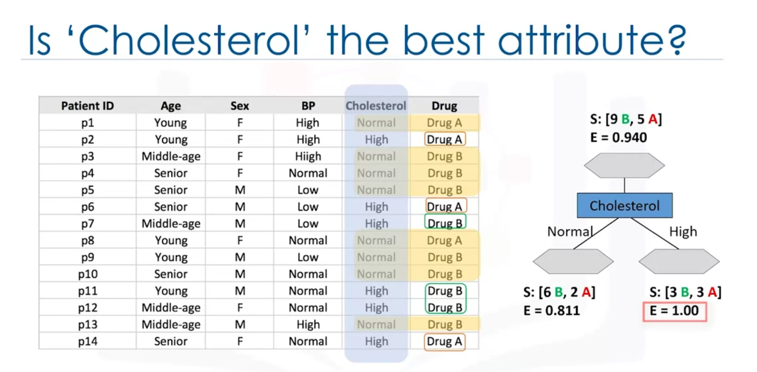

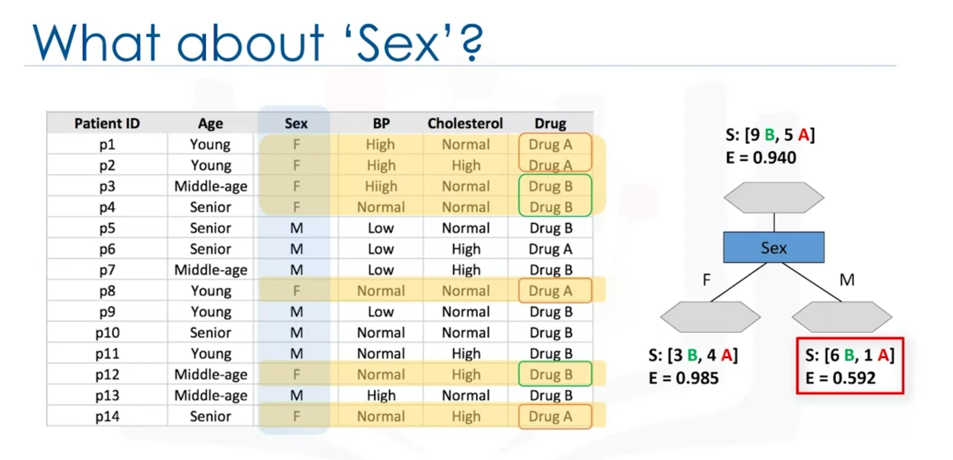

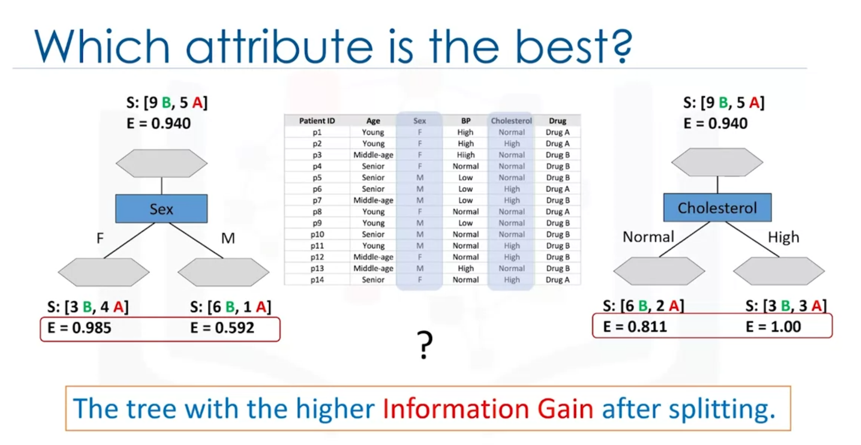

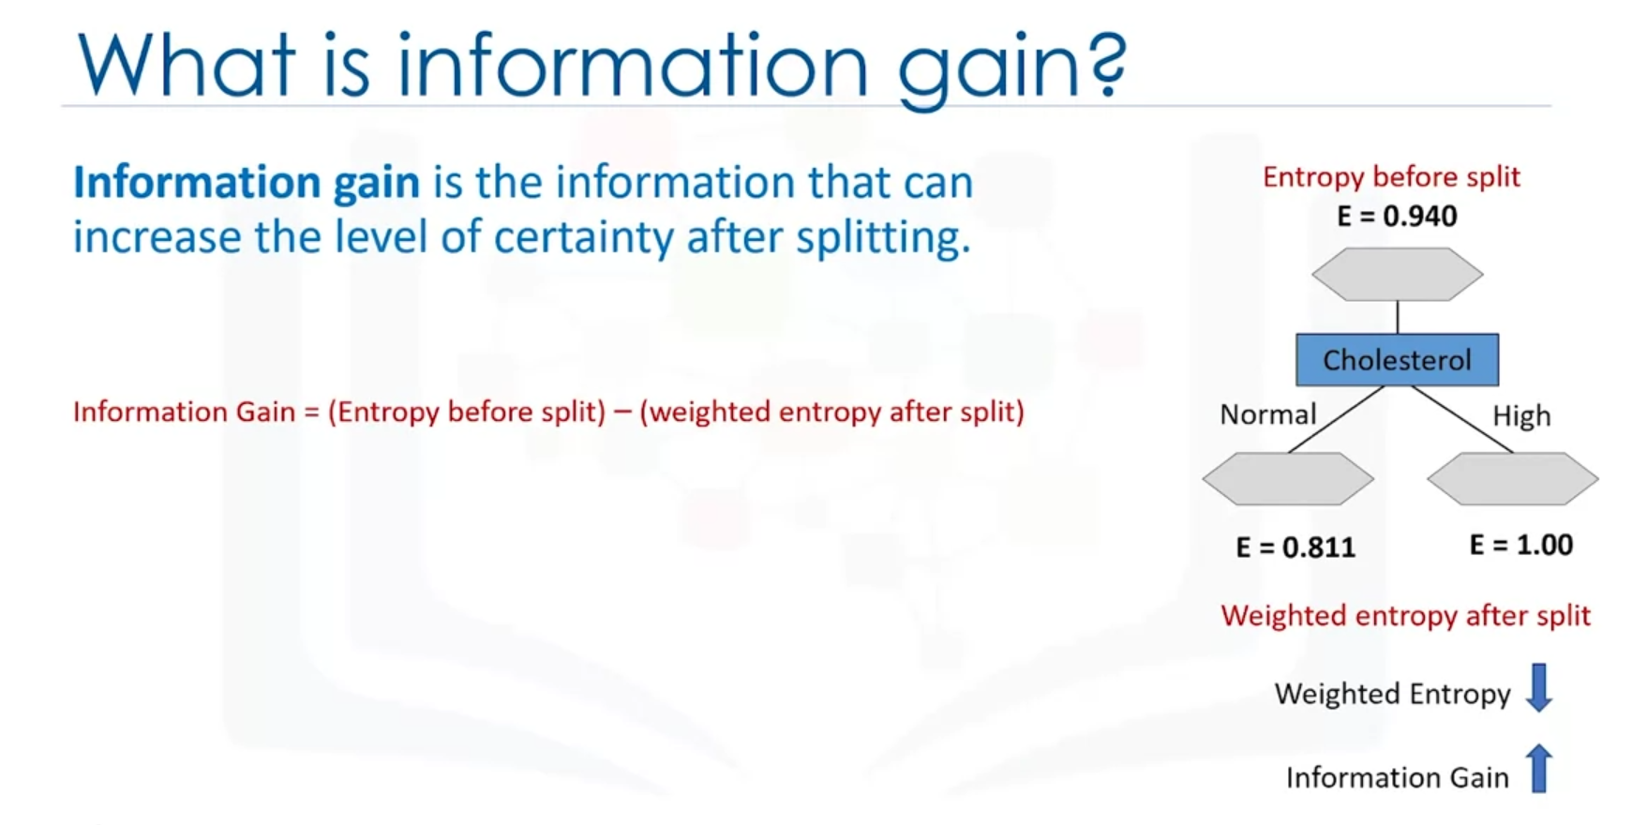

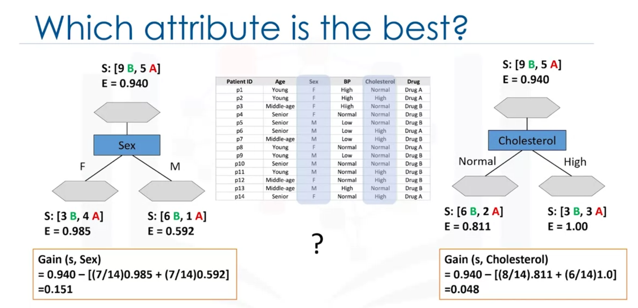

Higher is better.

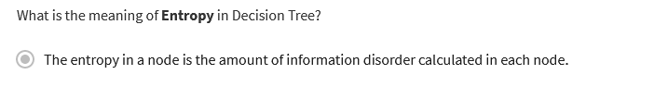

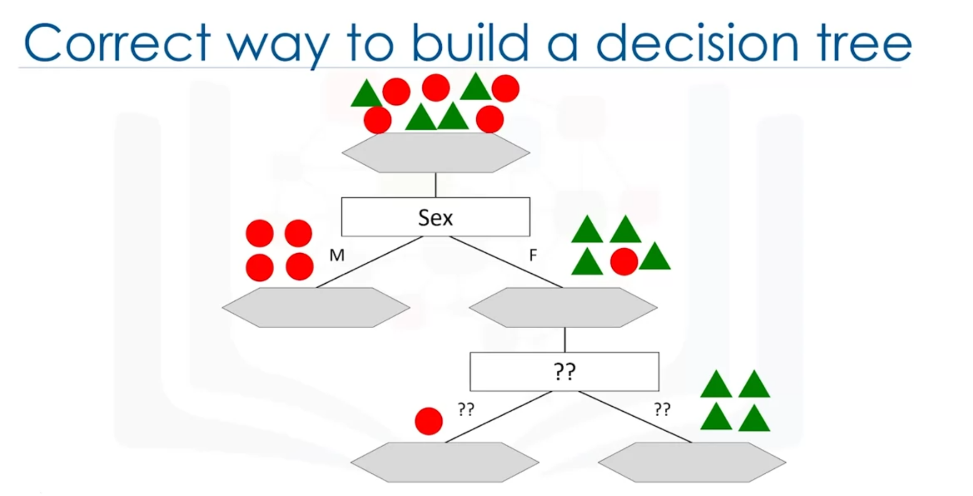

* kNN algorithm can be used to estimate values for a continuous target. kNN can be used for both classification and regression prediction tasks. In the case of a continuous target, the prediction is taken as the average or median of the nearest neighbours.
* If the information gain of the tree by using attribute A is 0.3, what can we infer? The entropy of a tree before split minus weighted entropy after split by attribute A is 0.3. This describes how information gain is calculated, measuring how much certainty has increased by making a split.
* When we have a value of K for KNN that’s too small, what will the model most likely look like? The model will be highly complex and captures too much noise. By looking at too few neighbours, we can capture an anomaly in the data, which means that prediction isn’t generalized enough.